

**Year 12 PHYSICS ATAR**

**Semester 1**

**Task 7: Test 2**

**TASK TYPE: Test**

**CONTENT: Gravity, circular motion and torque – 7%**

|  |  |  |
| --- | --- | --- |
|  | **Possible Marks** | **Your Mark** |
| **Total** | **45** |  |
| **Percentage** | **100%** |  |

**Student Name: ____________________________________**

**Date: ____________________________________**

**Teacher: J. Wijaya**

**Instruction:**

1. **Answer all questions.**
2. **All numeric answers are to be corrected to three significant figures unless specified. Estimated answers are to be corrected to two significant figures.**
3. Two bodies exert an attractive force on each other according to Newton’s Law of Universal Gravitation. Consider object X and object Y of mass ***M*** kilograms and 4***M*** kilograms respectively separated by a distance ***R*** metres. The gravitational force exerted by X on Y is ***F*** Newtons.

Y mass = 4***M*** X mass = ***M***

Answer the following questions in term of ***F***:

* 1. What is the force exerted by Y on X?

[1]

……………………………………………………………………………………………………………...

* 1. If the mass of X is doubled what will happen to the force exerted by X on Y?

[1]

……………………………………………………………………………………………………………...

* 1. If the distance is **also** halved, what will happen to the force exerted by Y on X?

[1]

……………………………………………………………………………………………………………...

1. A satellite is moving around the Earth in a circular orbit with a speed **V** ms-1. If the gravitational force of the Earth were to suddenly disappear, then the satellite would:

[3]

1. move radially (in the direction of the radius of a circle) outwards with a speed V ms-1.
2. spirally move away from the Earth.
3. move with a velocity V, tangentially to its circular orbit.
4. fall towards the surface of the Earth.

The correct answer is: ………………………………..

Explain your decision.

1. Below is a diagram of a specially designed truck collecting a “skip” from a building site. The skip is very heavy!

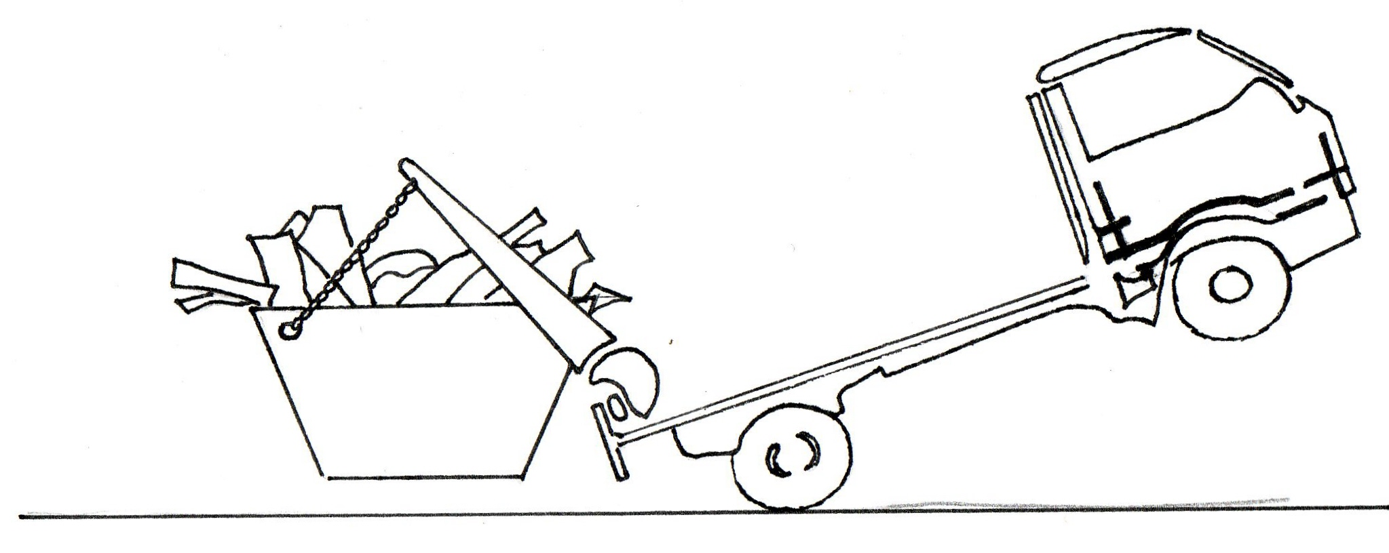

Explain why the truck is in the position as shown.

[3]

1. In 10 years, Global Positioning System [GPS] has gone from the USA military to being navigator tools to being a normal feature in many cars today. They work by transmitting a beam of EM radiation from an aerial on your car roof to one of 24 satellites surrounding the Earth.
   1. In the space below, prove the Kepler’s 3rd law:

[3]

* 1. If the height of any one of satellites is 19 000 km what is the time taken for a satellite to rotate around Earth once?

[2]

* 1. Why these satellites are said to be “freely falling” when they are not “falling” towards the Earth? Explain.

[2]

1. The planet Neptune has a mass of about 17 times that of Earth and a radius of 22.7 x 103 km.

Calculate the acceleration due to gravity at the surface of Neptune.

[3]

1. A castle has a steel cable attached from a fixed point (8 m from the floor) to raise and lower a long heavy drawbridge. The diagram is shown below.

Cable

Wall/Gate

River

Ground floor

The cable is attached at 1.00 m from the far end of the drawbridge. The mass of the drawbridge is 250 kg and the length is 9.5 m. When the drawbridge is horizontal, it makes 35o to the cable.

**Assume:** the mass of the drawbridge is evenly distributed and the mass of the steel cable is negligible.

* 1. Calculate the tension of the cable as it is **just** lifted off the ground floor.

[5]

* 1. A castle guard use a pulley to raise the drawbridge so that the angle of the cable and the drawbridge is increased. Would the tension of the cable continue to increase or decrease?

[3]

1. The diagram below shows a motorcyclist riding around a roundabout on a flat road.

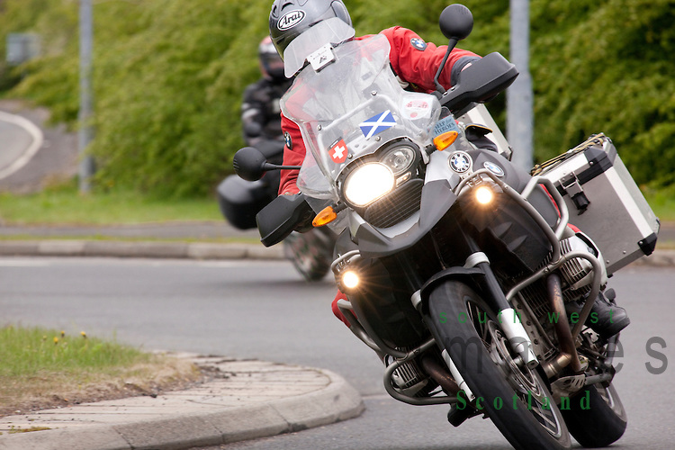

* 1. In the space below, using a free body diagram, to show all forces acting on the motorcyclist. Then show the net force and an **ESTIMATE** the angle of leaning.

[3]

* 1. Hence, **ESTIMATE** the velocity of the motorcyclist. Clearly show all other estimations.

[3]

1. The diagram below shows the proper bowling technique.

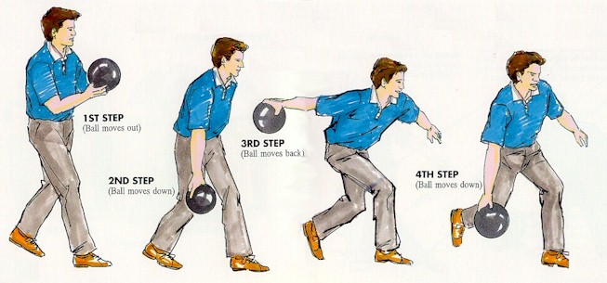

During the first three steps, the bowler needs to step forward to approach the lane at 3.00 m s-1 when released. During the fourth step, the bowler releases the ball and propels at 12.0 m s-1.

The arm of an average person is about 70.0 cm.

* 1. Explain why, using some mathematics equations, the bowler’s right arm receive the greatest tension just before the ball releases his/her hand.

[3]

* 1. Calculate the tension in the bowler’s arm, due to the bowling ball, as the ball is released. The ball has a diameter of 0.250 m and its mass is 6.00 kg.

[4]

1. A ball of mass m, suspended from a ceiling moves along a horizontal circle of radius r at a constant speed v. The string connecting the mass to the ceiling makes an angle of 20.0° to the vertical. The string has a length of 1.50 metres.

20.0°

Mass m

1.50 m

Speed v

Radius r

Calculate the time taken for the ball to make one revolution.

[5]

**End of the test**